**Data analytics Life Cycle**

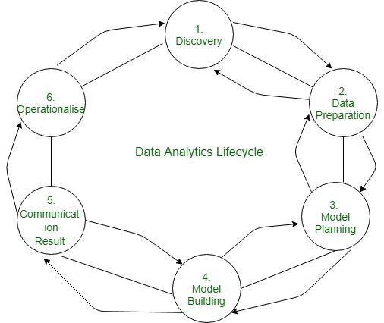

1. **Discovery**:

Discovery is the initial phase where you define the problem or objective of your analysis and gather relevant data. This stage involves understanding the business problem, identifying stakeholders, and determining the scope of the project. It's crucial to ask the right questions and define clear objectives to guide the rest of the data analytics process.

1. **Data preparation**:

Data preparation involves cleaning, transforming, and organizing the data to make it suitable for analysis. This stage includes tasks such as handling missing values, removing duplicates, and formatting data. The goal is to ensure that the data is accurate, complete, and in a format that can be used effectively for analysis.

1. **Model planning**:

Model planning is where you decide which analytical techniques or models to use based on the nature of your data and the problem you're trying to solve. This stage involves understanding the data, selecting appropriate algorithms or models, and defining the approach to be used for analysis. It's essential to consider factors such as the complexity of the problem, the availability of data, and the desired outcomes.

1. **Model building implementation**:

Model building implementation is where you build and test the chosen models using the prepared data. This stage includes tasks such as training machine learning algorithms or creating statistical models. The goal is to develop models that accurately capture patterns in the data and can make reliable predictions or insights.

1. **Quality assurance:**

Quality assurance involves validating the accuracy and reliability of the models built in the previous stage. This includes testing the models against known data, evaluating their performance metrics, and ensuring that they generalize well to new data. The goal is to ensure that the models are robust and reliable for making data-driven decisions.

1. **Documentation:**

Documentation is essential for capturing and communicating the entire data analytics process. This stage involves documenting data sources, data preparation steps, model selection criteria, and results. The documentation serves as a reference for future analysis and helps ensure transparency and reproducibility.

1. **Management approval:**

Management approval may be required before proceeding further with the data analytics project. This stage involves presenting the findings and proposed actions to management for review and approval. It's essential to communicate the value and potential impact of the analysis to gain buy-in from stakeholders.

1. **Installation:**

Installation is where the models or analytical tools developed in the previous stages are implemented in the production environment. This stage involves integrating the models into existing systems or workflows and ensuring that they are operational and accessible to end-users.

1. **Acceptance and operation:**

Acceptance and operation involve putting the models into operation and monitoring their performance over time. This stage includes user acceptance testing, ongoing monitoring, and maintenance of the models to ensure that they continue to meet the needs of the organization. It's essential to iterate and improve the models as new data becomes available or as the business requirements evolve.